INFLUHUNT - PRD
APPLICANT VIEW

Product Requirements Document

1. Objective
2. Release
3. Features
4. User flow and design
5. Sprint with user flow and deadline
6. Product Deployment and Deadline
7. Final testing and release date
8. Analytics
9. Future work

Objective
Vision | to develop a platform for job search in the creator economy.
Goals | As a user, can login and make a profile  As a user ,can view all the job listings with/without making a profile  As a user , search for a particular role  As a user, search for a particular influencer/ channel  As a user , apply filter on the basis of job type  As a user , apply filter on the experience required  As a user, view the job they’re interested in  As a user , click on the link to view the youtube channel/ instagram page  As a user, know in detail about the job  As a user, apply for the job  As a user, get a notification that the recruiter is interested.
Initiatives
Persona(s) | Who wants to find a job for a creator/ artistic role.

Release
Release | InfluHunt
Date | next sprint
Features | as a user  1.I can login and make a profile  2. can view all the job listings with/without making a profile  3. Can search for a particular role  4. Can search for a particular influencer/ channel  5. Can apply filter on the basis of job type  6. Can apply filter on the experience required  7. Can view the job they’re interested in  8. Can click on the link to view the youtube channel/ instagram page  9. Can know in detail about the job  10. Can apply for the job  11. Can get a notification that the recruiter is interested.
Dependencies | Release dependencies

Features
Feature | Find Opportunities CTA
Description | This will let the users view all the job opportunities without logging in or making a profile.
Purpose | This will help the customers to have a look at the website and explore it before they spend their time in making the profile.
User problem | For the niche category of jobs, users don’t have a proper platform where they could hunt for such type of artistic jobs.
Not doing | We can limit it to just a few job opportunities they can view, after that the customer needs to login/ create a profile.

Feature | Find Opportunities page
Description | This will let the users view in brief about the job opportunities. They can also apply a filter or search for a particular role/channel. The filter will contain- job type, experience level, WFH/WFO, paid/unpaid.
Purpose | To have an overview of the type of jobs available before reading it in detail.
User problem | For the niche category of jobs, users don’t have a proper platform where they could hunt for such type of artistic jobs.
Not doing | Semantic search (intelligent search) to be implemented next

Feature | Job overview card
Description | This will let the users view in brief about the job opportunities. The following fields must be displayed on the card:  - Name of the Youtube channel/Instagram Page/ Brand Name  - Job Role  - Niche of the brand  - WFH/WFO/Hybrid - if it is WFO the location must be mentioned  - Job Type- Full time/Part time/ Freelancer/ Internship etc  - Stipend/ Unpaid  - View details cta- this will open a page where the user can read about the job role in detail.
Purpose | To have an overview of the type of jobs available before reading it in detail.
User problem | For the niche category of jobs, users don’t have a proper platform where they could hunt for such type of artistic jobs.
Not doing

Feature | Job description page
Description | This will let the users read in detail about the job and the Youtube channel/Instagram Page/ Brand. Following are the sections on the page:  - All the details already present on the job card  - Link of the Youtube channel/Instagram Page/ Brand  - About the role in detail  - Skills required  - Platforms the applicant will be involved in- eg. instagram, youtube etc.)  - Apply now cta
Purpose | To read in-depth about the job role and apply for the job role
User problem | For the niche category of jobs, users don’t have a proper platform where they could hunt for such type of artistic jobs.
Not doing

Feature | Job description page
Description | This will let the users read in detail about the job and the Youtube channel/Instagram Page/ Brand. Following are the sections on the page:  - All the details already present on the job card  - Link of the Youtube channel/Instagram Page/ Brand  - About the role in detail  - Skills required  - Platforms the applicant will be involved in- eg. instagram, youtube etc.)  - Apply now cta  - Mail id of the hr
Purpose | To read in-depth about the job role and apply for the job role
User problem | For the niche category of jobs, users don’t have a proper platform where they could hunt for such type of artistic jobs.
Not doing

Feature | Apply now CTA- the profile was already created
Description | After clicking on the CTA, a pop up will be shown to confirm that the they have applied for the job and the recruiter will directly connect with them if interested. They will also get a notification if the recruiter has liked the profile.
Purpose | To apply directly without filling any lengthy forms. The recruiter will view the profile and connect with the applicant if they find them applicable.
User problem | For the niche category of jobs, users don’t have a proper platform where they could hunt for such type of artistic jobs.
Not doing | Providing transparency on the status of the application, allowing to modify the application as per role, connecting with the recruiter through chat.

Feature | Apply now CTA- the customer does not have a profile created already.
Description | After clicking on the CTA, the user will be redirected to the profile page where in they have to fill the personal details. The recruiter will be viewing this profile before making a choice of connecting. The follllowing details should be filled:  - Name*  - Photo*  - Email id*  - Phone number*  - Headline  - what best describes you  - Experiences  - About you*  - Location  - Skills*  - Links of your work  - Job type preference*  - Channel if any  - Age/Gender*  * -> Compulsory
Purpose | The recruiter will view the profile and connect with the applicant if they find them applicable.
User problem | For the niche category of jobs, users don’t have a proper platform where they could hunt for such type of artistic jobs.
Not doing | Making a profile calculator, which will show the % of details which are filled.

Note- The recruiter can directly connect with any of the applicants who have created a profile. If they like a profile, the recruiter can contact the person using the phone number or the mail id. - this is done to increase the chances of users logging in and creating a profile.

User flow and design (Image, Link)

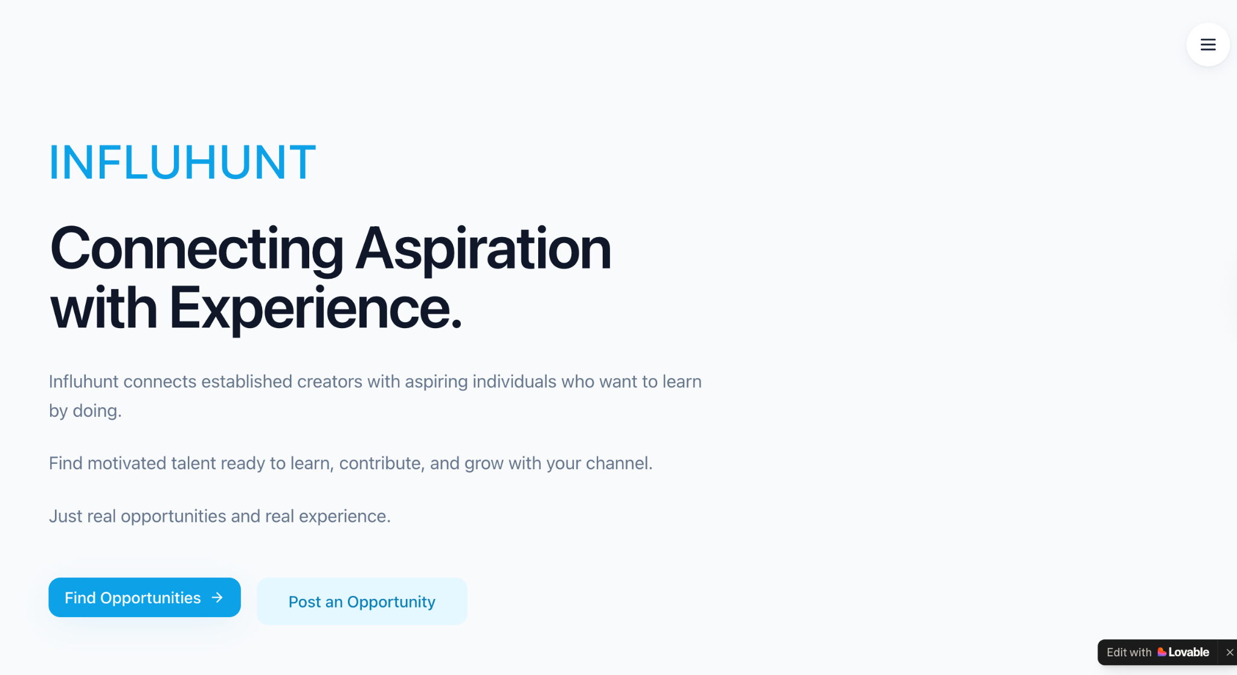

If the customer did not create a profile yet. (NLI Customer)
- There will be three CTA on the landing page- Find opportunity, Post an Opportunity & Sign in
- This PRD covers the scope of Find opportunities.
- On the find opportunity page the job cards will be displayed. On clicking on “View details”, the user will be redirected to the job details page.
- The user can view the job role in detail and also apply for the job
- On clicking on “Apply now”, the profile creation pop up must be displayed.
- After clicking on submit, a msg should be displayed on the screen to confirm the application and they can hear soon from the recruiter.
- If a recruiter likes their profile a notification is sent to the customer.
Note- For all the screens, a profile icon must be present on the right corner, where the customer can create/update their profile.

If the customer created an account already (LI customer)

- The find opportunities page will be the landing page.
- On the same page there will be a notification and profile icon
- Profile icon- to edit/update the profile section
- Notification - to notify the job roles applied, to notify if a recruiter had liked the profile
- If a recruiter had liked a profile- the name of the Youtube channel/Instagram Page/ Brand, mail id and job role(If present) will be displayed.
- Rest of the pages are similar to NLI
- After clicking on Apply now, the profile will be directly sent to the recruiter.

Sprint with user flow and deadline (link)

Name of feature | User flow | Task(Description) | Deadline(10/11/23)

Product Deployment

Product Deployment Platform name

Final testing and release date

Final Testing Date
Product Deployment Date
Product Release Date

Analytics

Hypothesis: We believe <this feature> will achieve <this outcome>.

Key performance indicator | Baseline | Target | Timeframe
Number of NLI users clicking on Find Opportunities CTA
Number of users making a profile
Number of users clicking on the filter
Number of users filtering basis job type
Number of users filtering basis experience level
Number of customers clicking on search
Number of customers clicking on View More
Number of users redirecting to the influencer’s page using the link provided
Number of customers clicking on Apply Now
Number of users clicking on the notification icon

Technologies
Technologies
Description
Purpose | this new feature will help us focus to increase engagement and activation  of a user
User tech | Technologies is being used in the user segment and third party services used (Link)
Service vendor tech | Technologies is being used in the Service Vendor and third party services used (Name and Link)
Admin problem | Technologies is being used in the Admin Problem and third party services used (Name and Link)
Business/Product tech | Technologies is being used in the Admin Problem and third party services used (Name and Link)  Example Mix Panel for product engagement and growth, Business Dashboard report, Salesforce of sales etc
Scalability of tech | What is the scalability of the technologies used.  Also mentioned if require to swift from one tech to another in future if so what will be another tech or service and why it is required to change

Future work
Future features | Purpose | Priority | Timeframe

